**LHC-300 EXTERNAL HARDWARE CALL-OUTS**

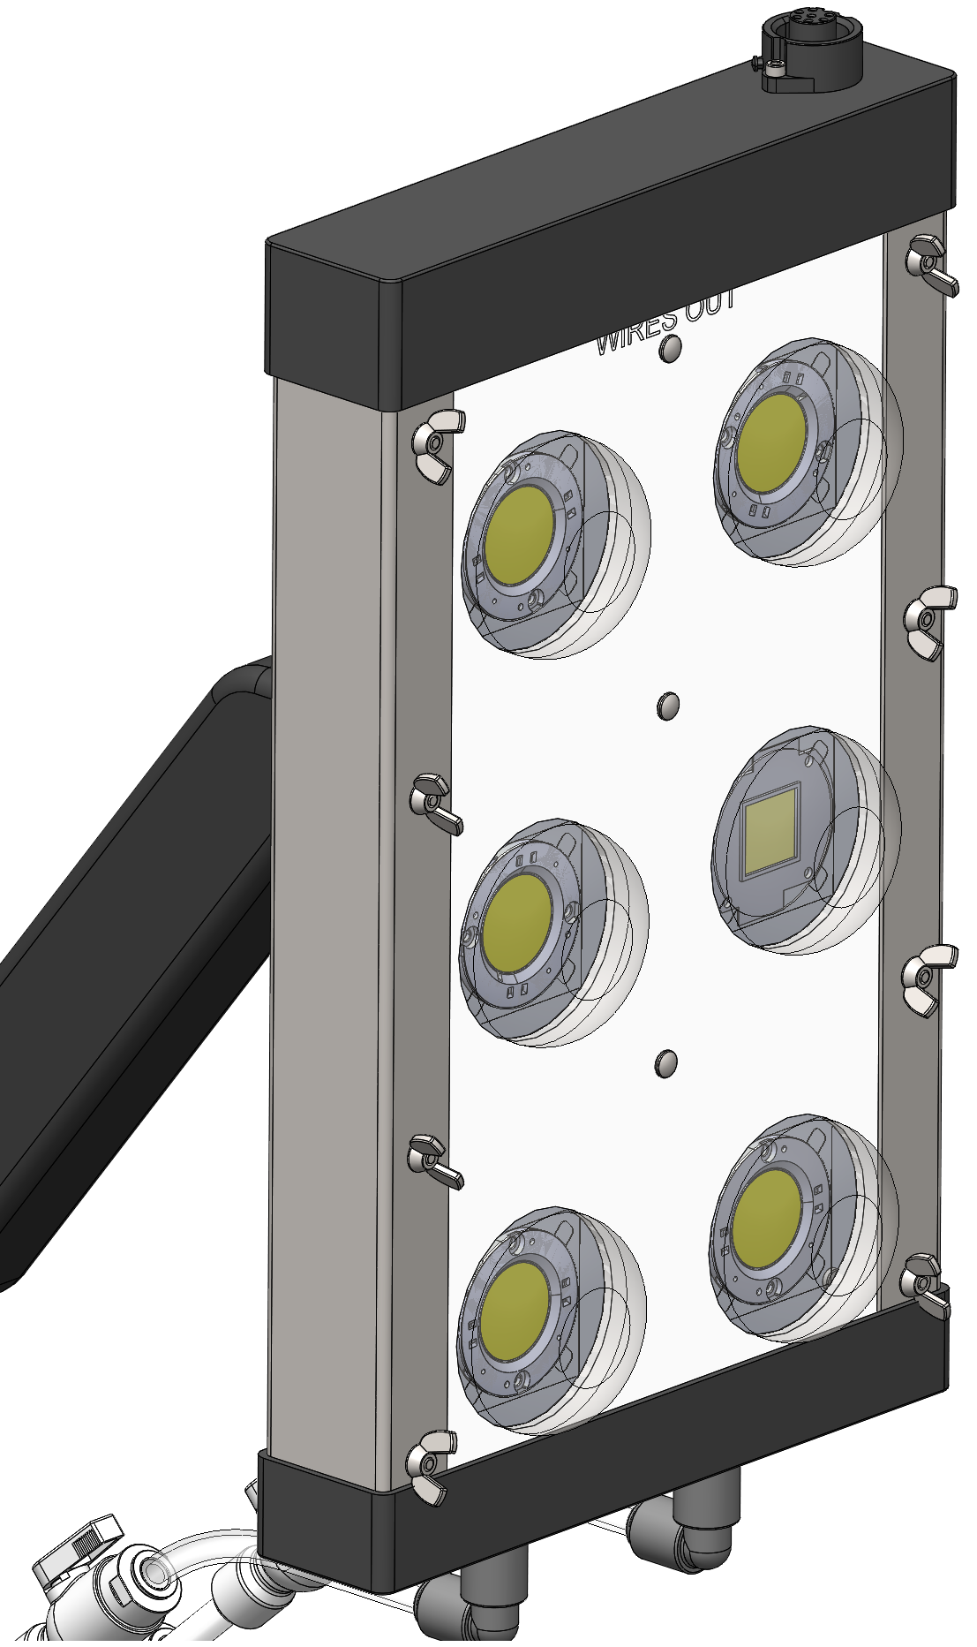

**6-32 SHC 3/8” LONG  
#92196A146**

**8-32 PAN HEAD PHILLIPS ¾” LONG  
#95345A548**

**8-32 PAN HEAD PHILLIPS ¾” LONG  
#95345A548**

**8-32 WING NUT  
#90866A009**

**8-32 PAN HEAD PHILLIPS 1.25” LONG  
#95345A555**

**¼” WIDE, 1/16” THICK FOAM, 7.25” LONG  
#8694K111**

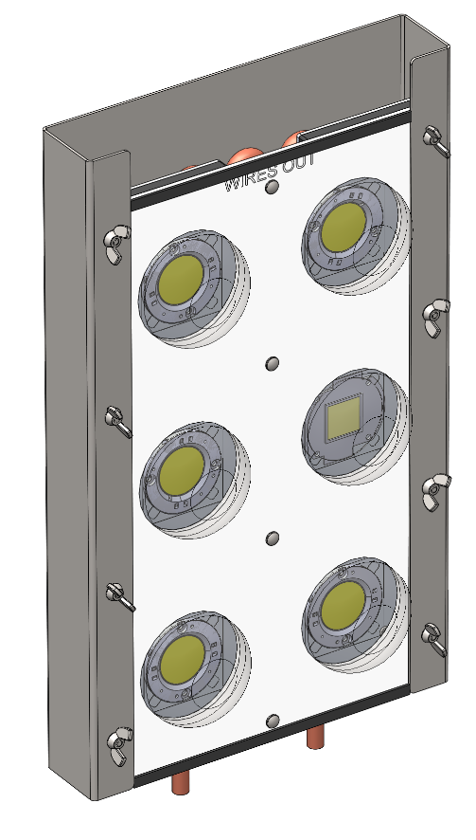

**LHC-300 INTERNAL HARDWARE CALL-OUTS**

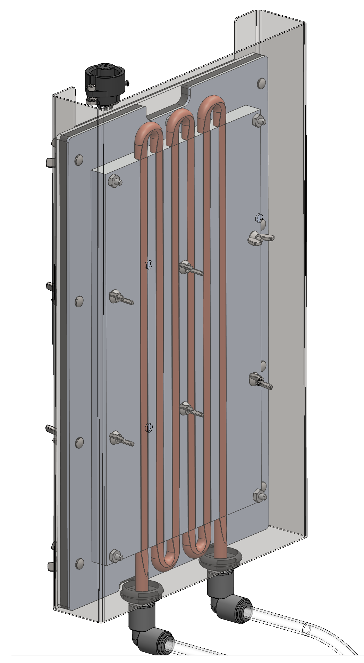

**8-32 LOCK NUT   
#96278A009**

**8-32 WING NUT  
#90866A009**

**8-32 WING NUT  
#90866A009**

**8-32 PAN HEAD PHILLIPS ¾” LONG  
#95345A548**

**HC-300 INTERNAL HARDWARE CALL-OUTS**

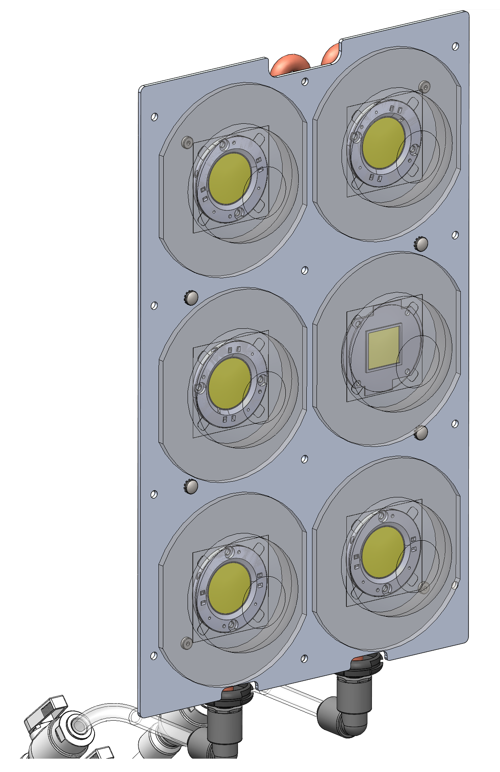

**8-32 LOW PROF. HEAD 1” LONG   
#90665A115**

**8-32 PAN HEAD PHILLIPS 1” LONG   
#95345A554**

**LEAVE HOLES EMPTY UNTIL THE ENTIRE “SANDWICH” IS READY FOR ASSEMBLY**